 | To: |  | City Executive Board
 | Date: |  | 19 September 2017
 | Report of: |  | Head of Financial Services
 | Title of Report: |  | Treasury Management Annual Report 2016/2017
 | Summary and recommendations
 | Purpose of report: |  | The report sets out the Council’s treasury management activity and performance for the financial year 2016/2017.
 | Key decision: |  | No
 | Executive Board Member: |  | Councillor Ed Turner
 | Corporate Priority: |  | An Efficient and Effective Council.
 | Policy Framework: |  | Treasury Management Strategy.
 | Recommendation(s):That the City Executive Board resolves to:
 | 1. | Note the report

Appendices
None

Executive Summary
- The Council held investments of £76.35 million as at 31st March 2017. Interest earned during the year was £0.86 million against a target of £0.74 million.
- The average rate of return on the Council’s investments in 2016/17 was 1.05% compared to 1.17% in 2015/16. This was above the Council’s performance target of 0.85% (i.e. 0.6% above base rate) and is primarily due to investments in property funds off-setting market investment rates which have fallen to very low levels.
- The Council has £0.17 million outstanding with the failed Icelandic Banks. Nothing was received in the year and the viability of the remaining balance is under review. If it is felt that this will not be recovered, the balance will be written off. Further information can be found in paragraphs 23-24.
- The Council held £198.5 million of fixed rate Public Works Loan Board (PWLB) debt as at 31st March 2017. The debt was borrowed in March 2012 to fund the buy-out of the Housing Revenue Account (HRA). All of the debt relates to Housing and the maturity profile ranges from 4 to 40 years. Interest paid on the debt in 2016/17 was £6.47 million.

Background
The primary principle governing the Council’s investment decisions is the Security of the investment, with Liquidity and Yield being secondary considerations.
The Council has a statutory duty to set, monitor and report on its prudential indicators in accordance with the Prudential Code, which aims to ensure that the capital investment plans of authorities are affordable, prudent and sustainable.
When considering whether to borrow, the Council’s Debt Strategy requires a number of factors to be considered. These include:
    - prevailing interest rates
    - the profile of the Council’s debt portfolio
    - the type of asset being financed
  - the availability of cash balances to finance capital expenditure.

The Council fully complied with its Treasury Management Strategy in relation to both debt and investment management in 2016/17.
The prudential indicators detailed in the body of this report compare the Council’s outturn position against the target set for 2016/17.
Financing the Capital Programme 2016/17
Table 1 below shows actual capital expenditure and financing compared to the original budget.
Table 1

Capital Expenditure | 2016/17 | 2016/17 | Variation
 | Original Budget | Actual
 | £'000 | £'000 | £'000
Non-HRA Capital Expenditure | 19,923 | 14,642 | -5,281
HRA Capital Expenditure | 22,168 | 17,884 | -4,284
Total Capital Expenditure | 42,091 | 32,526 | -9,565
Resourced by:
Developer Contributions | 3,635 | 1,565 | -2,070
Capital Receipts | 6,492 | 5,585 | -907
Capital Grants and contributions | 2,501 | 2,393 | -108
Major Repairs Reserve | 20,105 | 10,112 | -9,993
Prudential Borrowing | 5,588 | 2,243 | -3,345
Revenue | 3,770 | 10,628 | 6,858
Total Capital Resources | 42,091 | 32,526 | -9,565

The Council’s Overall Borrowing Need
The Council’s underlying need to borrow, or Capital Financing Requirement (CFR), is a gauge of the Council’s level of indebtedness. It represents all prior years’ net capital expenditure which has not been financed by other means, i.e. revenue, capital receipts, grants etc.
The CFR can be reduced by:
  - The application of additional capital resources, such as unapplied capital receipts; or
  - By charging a Minimum Revenue Provision (MRP), or a Voluntary Revenue Provision (VRP)
Table 2 below shows the Council’s CFR as at the 31st March 2017, this is a key prudential indicator, and shows that actual borrowing is below the CFR:

Table 2
CFR | 31st March 2017 | 31st March 2017 | Variation
 | Estimate | Actual
 | £'000 | £'000 | £'000
Opening Balance | 225,117 | 220,669 | (4,448)
Prudential Borrowing | 5,588 | 2,243 | (3,345)
Minimum Revenue Provision | (686) | (37) | (649)
CFR Closing Balance | 230,019 | 222,875 | (7,144)
External Borrowing | 198,528 | 198,528 | -
Variation | (31,491) | (24,347) | (7,144)

No new debt was taken out during 2016/17 and as at 31st March 2017 the Council’s total external debt was £198.5 million. This is below the CFR and indicates that the Council continues to internally borrow. The MRP was lower than that estimated due to a reassessment of the calculation on non-Housing assets transferred from the HRA to the General Fund.
Treasury Position at 31st March 2017
Whilst the Council’s gauge of its underlying need to borrow is the CFR, the treasury function manages the Council’s actual need to borrow by either:
  - Borrowing to the CFR;
  - Choosing to utilise temporary cash flow funds, instead of borrowing (known as “under borrowing”);
  - Borrowing for future increases in the CFR (borrowing in advance of need)
The Council’s treasury position as at the 31st March 2017 for both debt and investments, compared with the previous year is set out in Table 3 below:

Table 3

 | 31st March 2016 |  | 31st March 2017
Treasury Position | Principal | Average Rate | Principal | Average Rate
 | £'000 | % | £'000 | %
Borrowing
Fixed Interest Rate Debt | 198,528 | 3.15 | 198,528 | 3.15
Total Debt | 198,528 | 3.15 | 198,528 | 3.15
Investments
Fixed Interest Investments | 46,500 | 0.64 | 41,000 | 0.61
Variable Interest Investments | 7,760 | 0.44 | 10,360 | 0.56
Property Funds | 10,000 | 4.05 | 10,000 | 4.05
Total Investments | 64,260 | 1.17 | 61,360 | 1.05
Net Position | 134,268 |  | 137,168

The average investment rate shown above is 1.05% for 2016/17 which is above the Council’s target of 0.6% above base rate (0.85% in total).

Prudential Indicators and Compliance Issues
Some of the prudential indicators provide an overview, others a specific limit on treasury activity. These are detailed below:
Net Borrowing and the CFR – In order to ensure that borrowing levels are prudent, the Council’s external borrowing (net of investments) over the medium-term must only be for a capital purpose, and not exceed the CFR except in the short-term. In the short term the Council can borrow for cash flow purposes. Table 4 below highlights the Council’s net borrowing position against the CFR, and shows that it is significantly below the limit, due to the level of internal borrowing that has been undertaken.

Table 4
Net Borrowing & CFR | 31st March 2016 | 31st March 2017
 | Actual | Actual
 | £'000 | £'000
Total Debt | 198,528 | 198,528
Total Investment | 64,260 | 61,360
Net Borrowing Position | 134,268 | 137,168
CFR | 220,669 | 222,875
Under Borrowing plus Investments | 86,401 | 85,707

In the current climate, internal borrowing is preferable to borrowing externally as the interest rate payable on an external loan is much higher than that which can be earnt on investments. Therefore, forfeiting interest receivable on investments is more economical than paying additional interest charges for new external debt. Clearly, if the net borrowing position, interest rate position and/or CFR changed significantly, the prospect of taking on additional debt would be reviewed.
The Authorised Limit – The Authorised Limit is the ‘affordable borrowing limit’ required by S3 of the Local Government Act 2003. The Council does not have the power to borrow above this level unless it explicitly agrees to do so. Table 5 below demonstrates that during 2016/17 the Council’s gross borrowing was within its Authorised Limit. The Authorised Limit allows for some headroom above the Council’s projected CFR.

Table 5
Authorised Borrowing Limit (ABL) | 31st March 2016 |  | 31st March 2017
 | ABL | Borrowing | ABL | Borrowing
 | £'000 | £'000 | £'000 | £'000
Borrowing | 255,450 | 198,528 | 259,603 | 198,528
Other Long Term Liabilities | 0 | 0 | 0 | 0
Total Borrowed | 255,420 | 198,528 | 259,603 | 198,528
Amount under Limit | 56,922 |  | 61,075

The Operational Boundary Limit – the Operational Boundary Limit is the expected borrowing position of the Council during the year. It is possible to exceed the Operational Boundary Limit, for a short period of time, providing that the Authorised Borrowing Limit is not breached. Table 6 below shows the limits for the last two financial years. Actual borrowing remained unchanged at £198.5m, hence the limits were not breached during either period.
Table 6
Operational Boundaries | 31st March 2016 | 31st March 2017
 | £'000 | £'000
Borrowing | 253,420 | 253,603
Other Long Term Liabilities | 0 | 0
Totals | 253,420 | 253,603

Actual financing costs as a proportion of net revenue stream – this indicator identifies the trend in the net cost of capital against the net revenue stream and is an indicator of affordability. Table 7 below shows that for the General Fund, the ratio is negative as external loans have been repaid and investment income is positive. The HRA ratio has improved slightly due to an increasing income stream meaning that financing costs as a proportion have fallen.

Table 7
Actual Finance Costs | 2015/16 | 2016/17
 | £'000 | £'000
Indicators
Original Indicator - Authorised Limit | 255,420 | 259,603
Original Indicator - Operational Boundary | 253,420 | 253,603
Financing Costs as a proportion of Net Revenue Stream - General Fund | -3.6% | -4.30%
Financing Costs as a proportion of Net Revenue Stream - HRA | 16.8% | 16.0%

Icelandic Banks
During 2008/09 the Council invested £4.5 million with two of the now failed Icelandic banks: £3.0 million was deposited with Heritable Bank and £1.5 million with Glitnir Bank.
As at 3st March 2016, the Council had received approximately £2.94 million of its original Heritable Bank investment. . An outstanding balance of £0.06 million remains. The prospect of a full recovery is uncertain.
As at 31st March 2016, the Council had received approximately £1.39 million of its Glitnir investment. . An outstanding balance of £0.11 million remains with the prospect of full recovery uncertain.
Investment Income
The following graph shows the monthly average interest earned by the Council in comparison to the base rate and also in comparison to its benchmarks: 3-months Libid and 7-day Libid.

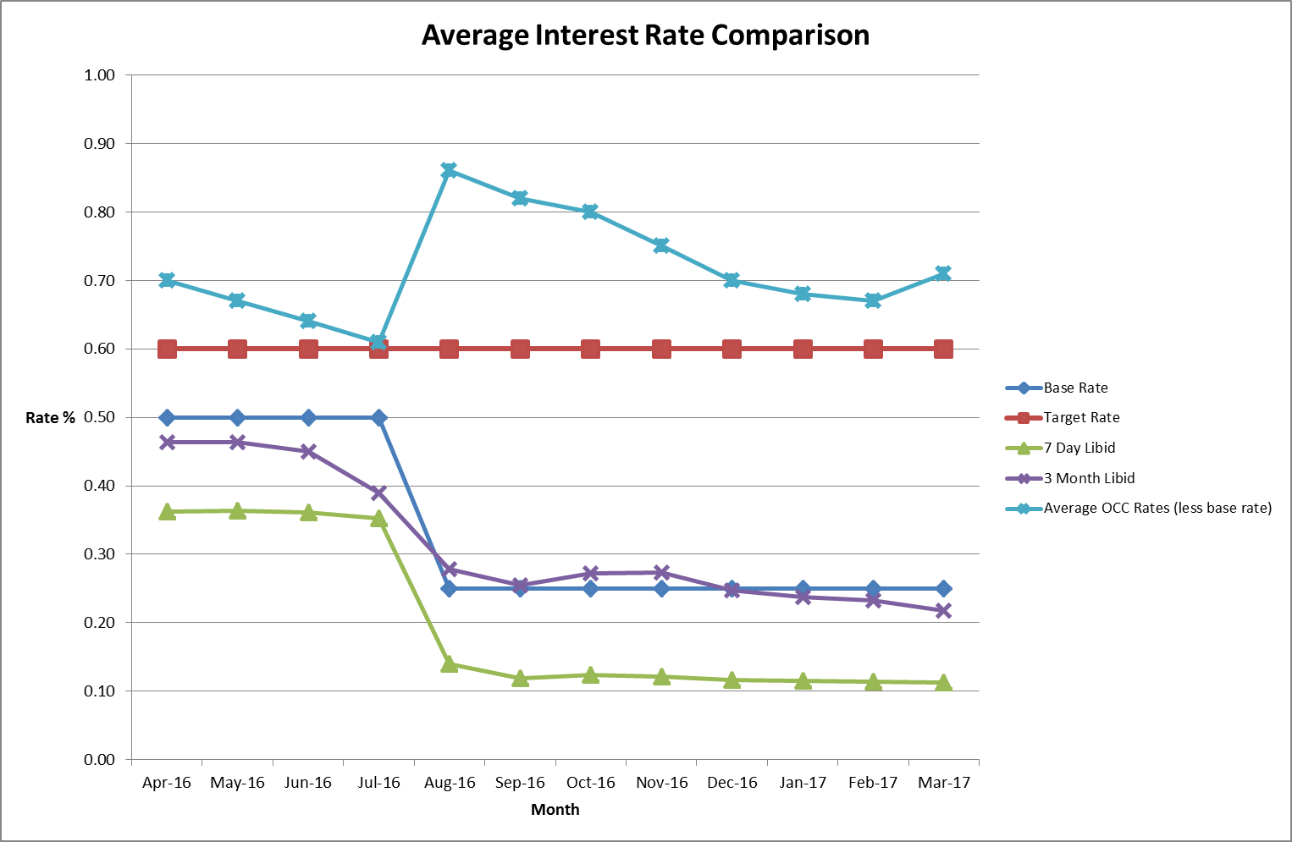

As illustrated above, the Council’s average monthly rate of return fluctuated throughout the year but remained above Base Rate at all times. The reason for the sudden spike in the average OCC rate is the fall in the Base Rate, against which the indicator is measured. Whilst the Base Rate fell by 0.25% in August 2016, the rates being received by the Council reduced gradually over time. This is partly due to the effect of continuing fixed term investments taken out prior to the Base Rate reduction.
The Council manages its investments in-house and invests with institutions listed in the Council’s approved counterparty list. The Council invests for a range of periods from overnight to 364 days, dependant on cash flow requirements, its view on interest rates and duration limits set out in the Council’s Investment Strategy.
During 2016/17, the Council maintained an average investment balance of £76.9million and received an average return of 1.04%. This is above the target of 0.85% and is mainly due to investment in property funds. It is important to note that market rates have continued to drop throughout the financial year and that for many of the approved counterparties, the Council has not been able to achieve the same rate of return as in previous periods.
The Property Funds are classified as Non-specified Investments within the approved Strategy. The current rate of return on the investments is circa 4.05% per annum. The capital value of the Communities, Churches and Local Authorities (CCLA) Fund has increased by 26.32% between April 2013 and March 2017. However, the overall fund value has slightly decreased since 2015/16, due to uncertainties in the property market, following the referendum vote to leave the EU, which affected the price of property. Fluctuations in value are to be expected with property fund investments over the short term. Property funds are a long term investment and any gains and losses in fund value should be considered over the long term.
The overall value of the Lothbury property fund investment has increased by 17.39% since inception in August 2014, but during 2016/17, fluctuations were also seen in value for the same reasons as with CCLA.
The Lothbury property fund has subsequently exceeded its pre-referendum valuation. The CCLA fund has been slower to recover, due to the type of property assets held in the fund, but its valuation is now also trending upwards.
Actual investment income for 2016/17 was £0.86 million; this was marginally higher than the budget estimate of £0.74 million. This is because although there was a reduction in the Base Rate rise, fixed term investments protected the Council’s position. Also in 2016/17 the Council invested in a higher yield cash fund instead of just using money market funds for liquid cash which boosted investment returns. Market rates continue to be very low and as security of investment is the Council’s primary concern, it has not always been possible to invest cash at more favourable rates.
Fluctuations in the Council’s balances have been managed through a mix of instant access and notice accounts, money market funds and short term deposits (up to 364 days). This approach is in line with the Investment Strategy approved by Council.

Interest Rates since 31st March 2017
The Council takes advice from Capita on the appropriate durations to place investments with counterparties. These durations and also the availability of individual counterparties are subject to change dependant on market conditions and the credit ratings of the individual institutions. This means that the investment portfolio has to be actively managed to ensure both the availability of enough suitable counterparties and that the Council achieves the best interest rates possible within the agreed security and liquidity parameters.
There have been no further changes to Base Rate since the Bank of England reduced it to 0.25% in August 2016. Capita’s current view is that it will remain at 0.25% until end of March 2019 at which point they predict a rise to 0.50%, rising again to 0.75% by December 2019.
Under current market conditions, Money Market Funds (MMFs) are paying higher interest rates than many three-month investments and are only marginally lower than the average six-month rate. MMFs are amongst the most liquid of the Council’s investment portfolio; they do not require the Council to give notice and, providing the Council requests funds by midday, the investment will be transferred into the Council’s bank account that same day. MMFs are ordinarily used to provide cash flow flexibility to allow money to be accessed and invested quickly and to deal with fluctuations in cash flow. However, in order to allow for a diversified portfolio and to spread risk, the Council continues to place fixed term deposits and certificates of deposit with approved counterparties. Notice accounts are also used as these tend to offer a more favourable rate than fixed deposits and are reviewed regularly to ensure that cash remains liquid.

Financial implications
- These are set out within the body of the report.

Legal issues
- The Council is required to report on its Treasury Management function on an annual basis. This report meets that requirement.

Level of risk
- There are no risks in connection with the report’s recommendations. Risk assessment and management is a key part of Treasury Management activity, especially in the selection of counterparties when investment is being considered. The Council uses external advisors and counterparty credit ratings issued by the rating agencies to assist in this process.

Equalities impact
- There is no equalities impact relating to this report.

Report author | Bill Lewis
Job title | Financial Accounting Manager
Service area or department | Financial Services
Telephone | 01865 252607
e-mail | blewis@oxford.gov.uk

Background Papers: None

